SKIN DISEASES IDENTIFICATION USING IMAGE ANALYSIS

A Convolution Neural Network problem



**Deep learning allows machines to solve complex problems even when using a data set that is very diverse, unstructured and inter-connected.**

**Python is a high-level programming language designed to be easy to read and simple to implement. It is open source, which means it is free to use, even for commercial applications.**

**INDEX**

1. **INTRODUCTION**

**1.1 Overview**

**1.2 Purpose**

**2. LITERATURE SURVEY**

**2.1 Existing problem**

**2.2 Proposed solution**

**3. THEORITICAL ANALYSIS**

**3.1 Block diagram**

**3.2 Hardware/Software designing**

**4. EXPERIMENTAL INVESTIGATION**

**5. FLOWCHART**

**6. RESULT**

**7. ADVANTAGES AND DISADVANTAGES**

**8. APPLICATIONS**

**9. CONCLUSION**

**10. FUTURE SCOPE**

**11. BIBILOGRAPHY**

**APPENDIX**

**SOURCE CODE**

**1. INTRODUCTION:**

**1.1 Overview:**

In this contemporary world, skin diseases are mostly found in humans, animals, and plants. Skin diseases are among the most common health problems worldwide. A skin disease is a particular kind of illness caused by bacteria or an infection. These diseases like psoriasis, ringworm, yeast infection, brown spot, allergies, eczema etc. have various dangerous effects on the skin and keep on spreading over time. It becomes important to identify these diseases at their initial stage to control it from spreading.

These diseases are identified by using many advanced technologies such as image processing, data mining, convolutional neural networks (CNN) etc. Image processing has played a major role in this area of research and has widely used for the detection of skin diseases. Techniques like filtering, segmentation, feature extraction, image pre-processing and edge detection etc. are part of image processing and are used to identify the part affected by disease, the form of affected area, its affected area color etc.

This project presents a survey of various skin disease diagnosis systems using image processing techniques in recent times. A comprehensive study of a number of skin disease diagnosis systems are done in this project, with different methodologies and their performances.

**Computer Based Diagnosis of Skin Disease**

With the increase in medical technology the concept of computer being used for the diagnosis of skin diseases has been around recently. Use of computer technology can make it simpler to detect the diseases just from the images of the infected skin image and could assist the human’s ability to analyze complex information. Artificial Intelligence is taking up automation in all fields of application even in the healthcare field.3

A computer can efficiently and effortlessly interpret a lot of images where it is difficult for the human to interpret such a high number of data and look into the details of the image inside. Therefore Computer-Aided-Detection and Computer-Based-Diagnosis have become desirable and are under development by many research groups.4 Computer based diagnosis have proven to be very helpful in disease diagnosis.

The most prevalent technology which is being used for the prediction is Artificial Intelligence using Machine Learning. Artificial Intelligence uses learning methods to learn about the images to predict the diseases based upon the common patterns. The machine interprets the images and its slices and processes the image and predicts.

**Machine Learning**

Machine Learning is that branch of computer studies that gives the potentiality to the computer to grasp without being characteristically programmed. Machine learning is employed in a wide range of computing functions where building and designing specific algorithms with better performances is difficult or impractical. Machine Learning is also firmly attached to computational statistics which makes prediction through computers easier and feasible. In commercial terms Predictive Analysis is machine learning used to design multiple algorithms and models that greatly helps the process of prediction. Here the machine learns itself and divide the data provided into the levels of prediction and in a very short period of time gives the accurate results.

***Deep Learning***

Deep learning is a part of the broader family of machine learning wherein the learning can be supervised, unsupervised or semi supervised. Deep learning unlike machine learning uses a large dataset for the learning process and the number of classifiers used gets reduced substantially.6 The training time for the deep learning algorithm increases because of the usage of the very large dataset. Deep learning algorithm chooses its own features unlike the machine leaning making the prediction process easier for the end user as it does not use much of pre-processing.

**1.2 Purpose:**

In general, most of the common people do not know the type and stage of a skin disease. Some of the skin diseases show symptoms several months later, causing the disease to develop and grow further. This is due to the lack of medical knowledge in the public. Sometimes, a dermatologist (skin specialist doctor) may also find it difficult to diagnose the skin disease and may require expensive laboratory tests to correctly identify the type and stage of the skin disease. The advancement of lasers and photonics based medical technology has made it possible to diagnose the skin diseases much more quickly and accurately. But the cost of such diagnosis is still limited and very expensive.

To overcome this problem , we proposed an image processing method to detect skin diseases.This method takes the digital image of disease affected skin area, then use image analysysus to identify the type of disease. The extraction of features plays a key role in helping to classify skin diseases. Computer vision has a role in the detection of skin diseases in a variety of techniques.

**2. LITERATURE SURVEY:**

**2.1 Existing problem:**

* First, skin diseases are so common and patients present in such large numbers in primary care settings that ignoring them is not a viable option. Children, in particular, tend to be affected, adding to the burden of disease among an already vulnerable group.
* Second, morbidity is significant through disfigurement, disability, or symptoms such as intractable itch, as is the reduction in quality of life. For instance, the morbidity from secondary cellulitis in lymphatic filariasis, which may lead to progressive limb enlargement, is severe, and subsequent immobility contributes to social isolation.
* Third, the relative economic cost to families of treating even trivial skin complaints limits the uptake of therapies. Generally, families must meet such costs from an overstretched household budget, and such expenses in turn reduce the capacity to purchase such items as essential foods .
* Fourth, screening the skin for signs of disease is an important strategy for a wide range of illnesses, such as leprosy, yet a basic knowledge of the simple features of disease whose presenting signs occur in the skin is often lacking at the primary care level.

A shortage of elementary skills in the management of skin diseases is a further confounding problem. A number of studies assessing success in the management of skin diseases.

**2.2 Proposed Solution:**

Several researchers have proposed image processing-based techniques to detect the type of skin diseases. In, a system is proposed for the dissection of skin diseases using color images without the need for doctor intervention. The system consists of two stages, the first the detection of the infected skin by uses color image processing techniques, k-means clustering and color gradient techniques to identify the diseased skin and the second the classification of the disease type using convolutional neural networks. The system was tested on five types of skin diseases with accuracy of 91%

Melanoma is type of skin cancer that can cause death, if not diagnose and treat in the early stages. The various segmentation techniques that could be applied to detect melanoma using image processing. Segmentation process is described that falls on the infected spot boundaries to extract more features. The development of a Melanoma diagnosis tool for dark skin using specialized algorithm databases including images from a variety of Melanoma resources. Similarly, classification of skin diseases such as Melanoma, Basal cell carcinoma (BCC), Nevus and Seborrheic keratosis(SK). It yields the best accuracy from a range of other techniques. Therefore, proposed a computer system that automatically detects skin disease and determines its severity. The system consists of three stages, the first effective segmentation by detecting the skin, the second extract a set of features, namely colour, texture, borders and third determine the severity of disease. An application is built where an user can upload an image from UI, then image will be sent to the trained model. The model analyze the image and detect the skin disease.

**3. THEORITICAL ANALYSIS:**

**3.1 Block Diagram:**

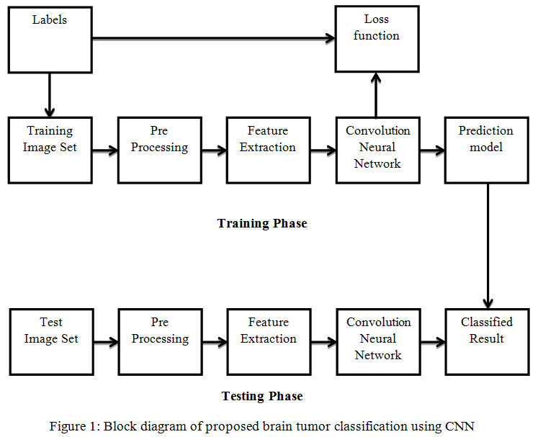

**3.2 Hardware/Software Designing:**

The model is designed using Jupyter Notebook in Anaconda software, which is an open-source distribution of the Python and the other programming languages for scientific computing. Deployment of aplication building is done using Flask which is a web-framework that provides tools,libraries and technologies that allow the developer to build a web application.This web application can be any website.

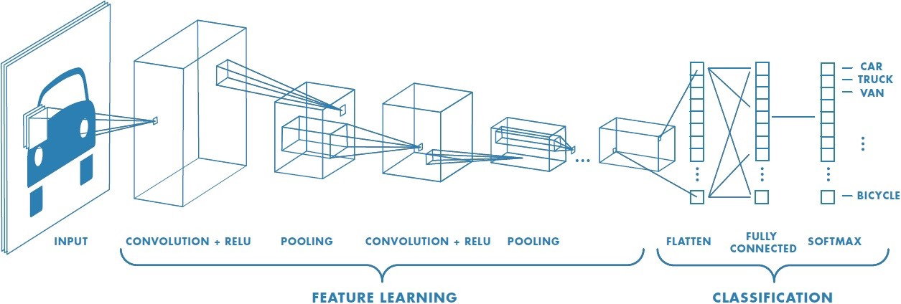

**Standard architecture of a CNN**

Convolutional Neural Networks are different from normal neural networks because they contain a special type of layer called a Convolutional Layer, which contains a filter that is able to understand certain types of patterns in the image.

Apart from convolutional layers, CNN’s contain a couple other layers, namely pooling and classification layers.

Pooling layers are really important in making sure that it doesn’t take forever to train your CNN. They do this by reducing the dimensions of the image.

It works quite similarly to a convolutional layer, where a filter passes over the image, except now, the filter passes over the data, extracts the most important information, and puts it into a smaller sized matrix.



**A graphical demonstration of a filter**



**A Pooling Layer reducing a feature map by taking the largest value.**

All these layers are joined together at the end, into a [softmax](https://medium.com/data-science-bootcamp/understand-the-softmax-function-in-minutes-f3a59641e86d) function(classification layer) which produces the final classification.

**4. EXPERIMENTAL INVESTIGATION:**

In order to identify the different skin diseases, "Actinic Keratosis, Dermatofibroma, Melanoma, Seborrheic Keratosis, Squamous Cell Carcinoma" are selected as the research objectives. Four hundred Forty one images are selected to be identified(trained) accordingly. One hundred ninety seven images are testing samples to identify "Actinic Keratosis, Dermatofibroma, Melanoma, Seborrheic Keratosis, Squamous Cell Carcinom

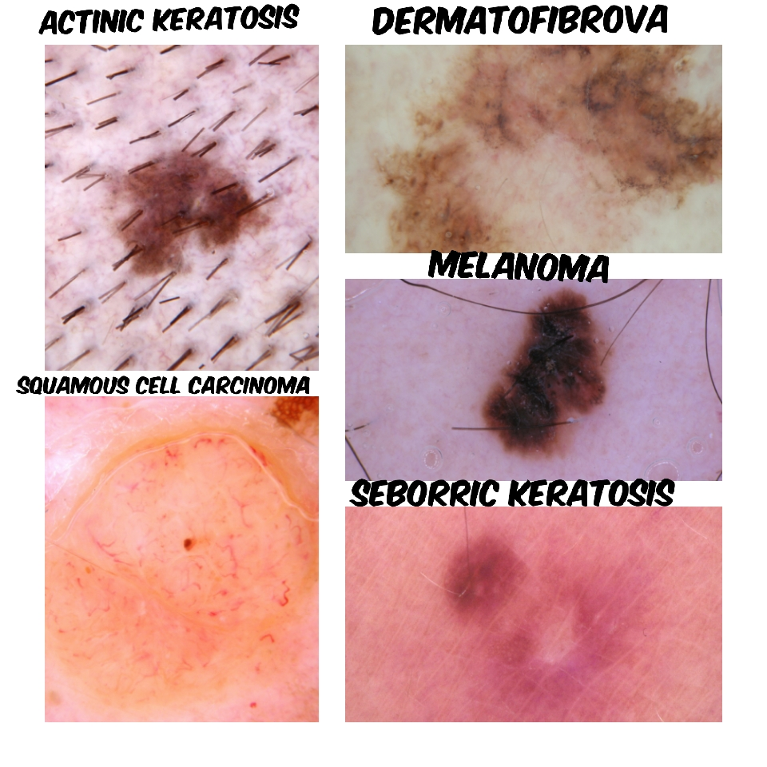

|  |  |  |  |  |  |
| --- | --- | --- | --- | --- | --- |
| METHOD | ACTINIC KERATOSIS | DERMATO FIBROMA | MELANOMA | SEBORRHEIC KERATOSIS | SQUAMOUS CELL CARCINOMA |
| NUMBER OF TESTS | 90 | 90 | 90 | 90 | 90 |
| RECOGNITION ON NUMBERS | 89 | 88 | 80 | 86 | 88 |
| RECOGNITION ON RATE(%) | 93% | 91% | 86% | 90% | 92% |

**5. FLOWCHART:**

A small grid of parameters called kernel, an optimizable feature extractor, is applied at each image position, which makes CNNs highly efficient for image processing, since a feature may occur anywhere in the image. As one layer feeds its output into the next layer, extracted features can hierarchically and progressively become more complex. The process of optimizing parameters such as kernels is called training, which is performed so as to minimize the difference between outputs and ground truth labels through an optimization algorithm called backpropagation and gradient descent, among others.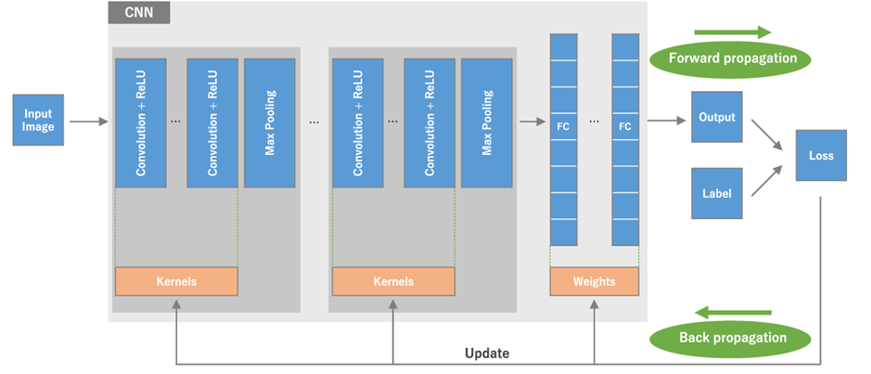

An overview of a convolutional neural network (CNN) architecture and the training process. A CNN is composed of a stacking of several building blocks: convolution layers, pooling layers (e.g., max pooling), and fully connected (FC) layers. A model’s performance under particular kernels and weights is calculated with a loss function through forward propagation on a training dataset, and learnable parameters, i.e., kernels and weights, are updated according to the loss value through backpropagation with gradient descent optimization algorithm. ReLU, rectified linear unit.

The CNN architecture includes several building blocks, such as convolution layers, pooling layers, and fully connected layers. A typical architecture consists of repetitions of a stack of several convolution layers and a pooling layer, followed by one or more fully connected layers. The step where input data are transformed into output through these layers is called forward propagation.Although convolution and pooling operations described in this section are for 2D-CNN, similar operations can also be performed for three-dimensional (3D)-CNN.

**Convolution layer** **:**

A convolution layer is a fundamental component of the CNN architecture that performs feature extraction, which typically consists of a combination of linear and nonlinear operations, i.e., convolution operation and activation function.

### Pooling layer :

A pooling layer provides a typical downsampling operation which reduces the in-plane dimensionality of the feature maps in order to introduce a translation invariance to small shifts and distortions, and decrease the number of subsequent learnable parameters. It is of note that there is no learnable parameter in any of the pooling layers, whereas filter size, stride, and padding are hyperparameters in pooling operations, similar to convolution operations.

#### Max pooling :

The most popular form of pooling operation is max pooling, which extracts patches from the input feature maps, outputs the maximum value in each patch, and discards all the other values .

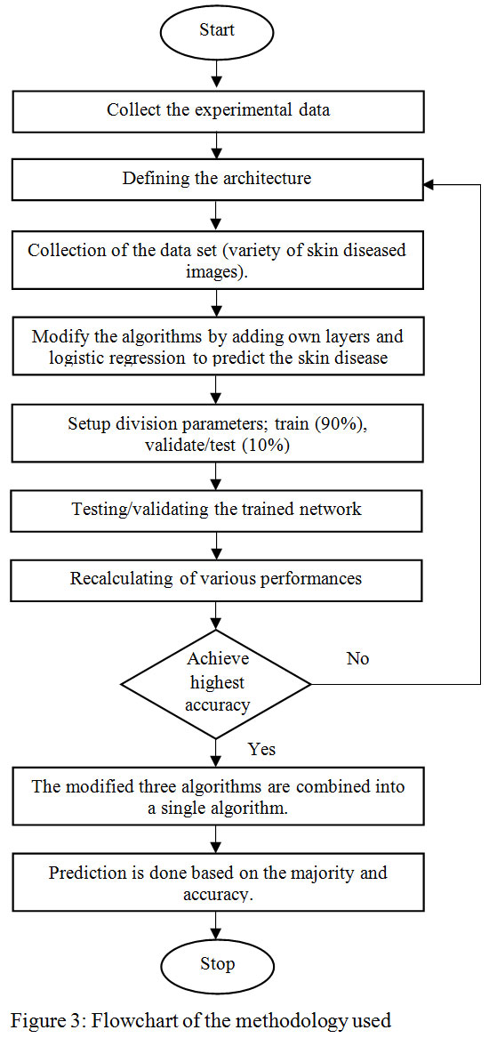

**6. RESULT:**

This section displays accuracy results for the CONVOLUTION NEURAL NETWORK constructed during this project. Neural network accuracy, while not good enough to confidently identify "the pictures in the skin diseases dataset, proved that the classification using a CNN is possible. The result provides a proper framed network,hidden layers, or larger input images,a convolution neural network constructed using six layers,has the capability of classification.

This study projects a method that uses techniques related to computer vision to distinguish different kinds of dermatological skin abnormalities. We have employed various types of Deep learning algorithms for feature extraction and learning algorithm for training and testing purpose. Using the state of the art architecture considerably increases the efficiency up to 88-93 percentage.

**7. ADVANTAGES AND DISADVANTAGES**

|  |  |
| --- | --- |
| ADVANTAGES | DISADVANTAGES |
| Easy model building with less formal statistical knowledge required. | Clinical interpretation model parameters can be black boxes. |
| Capable of capturing interactions between predictors. | Sharing an existing ANN model is difficult. |
| Capable of capturing non-linerarities between predictors and outcomes. | Prone to overfitting due the complexity of model structure. |

**8. APPLICATIONS:**

Healthcare is too expensive. Even in countries where healthcare is free, waiting for a professional diagnosis can take lot of time.so, many feel that self-assessment is a better option.

Professional diagnosis can be practically helpful for a number of reasons.But, These mainly relate to insurance, access to services, and other legal issues.

Self diagnosis are obvious. You can type in your symptoms and get a quick and easy diagnosis of whatever ailment is bothering you without getting a doctor’s bill. It saves you money, time and worries over going to a doctor’s office. For people who are scared to go to the doctor, or need to save their money, this can be a saving grace.

**9. CONCLUSION:**

Convolutional neural networks (CNNs) have accomplished astonishing achievements across a variety of domains, including medical research, and an increasing interest has emerged in radiology. Although deep learning has become a dominant method in a variety of complex tasks such as image classification and object detection, it is not a panacea. Being familiar with key concepts and advantages of CNN as well as limitations of deep learning is essential in order to leverage it in radiology research with the goal of improving radiologist performance and, eventually, patient care.

In this work a model for identification of skin diseases is done using image analysis and Convolutional Neural Networks. It is found that by using the Convolutional neural networks we can achieve a higher accuracy rate and also we can go for the prediction of many more diseases than with any other previous models done before. As the previous models done in this field of application were able to report a maximum of six skin diseases with a maximum accuracy level of 75%. By implementing deep learning algorithm we are able to predict as many as 20 diseases with a higher accuracy level of 88%. This proves that deep learning algorithms have a huge potential in the real world skin disease diagnosis. If even a better system with high end system hardware and software with a very large dataset is used, the accuracy can be increased considerably and the model can be used for clinical experimentation as it does have any invasive measures.

**10. FUTURE SCOPE:**

Detection of skin disease is one of the major problems in the medical industry and can be healed and retrieved if properly diagnosed at an early point. Literature study demonstrates that different skin disease observation techniques are being used. However, there is still a great need to classify skin diseases at an early point. Machine learning algorithms have the potential to have an impact on early detection of skin diseases. It can assist people make real-time adjustments to their skin. If embraced well, the techniques will certainly provide appropriate assistance and a unified approach to skin problems prevention. This will assist patients and physicians cure skin diseases in a timely manner. Research and execution of limited medical information are accessible. If more real-time data are available in the future, the detection of skin disease can be explored with recent advances in AI and the benefits of diagnosis assisted with AI.

**11. BIBILOGRAPHY:**

**References:**

Dataset downloaded from: kaggle

(<https://www.kaggle.com/nodoubttome/skin-cancer9-classesisic>)